1. The 'ls' command in Linux allows users to view the contents of a directory, providing information such as file names, sizes, permissions, and timestamps, aiding in navigation and file management within the operating system.

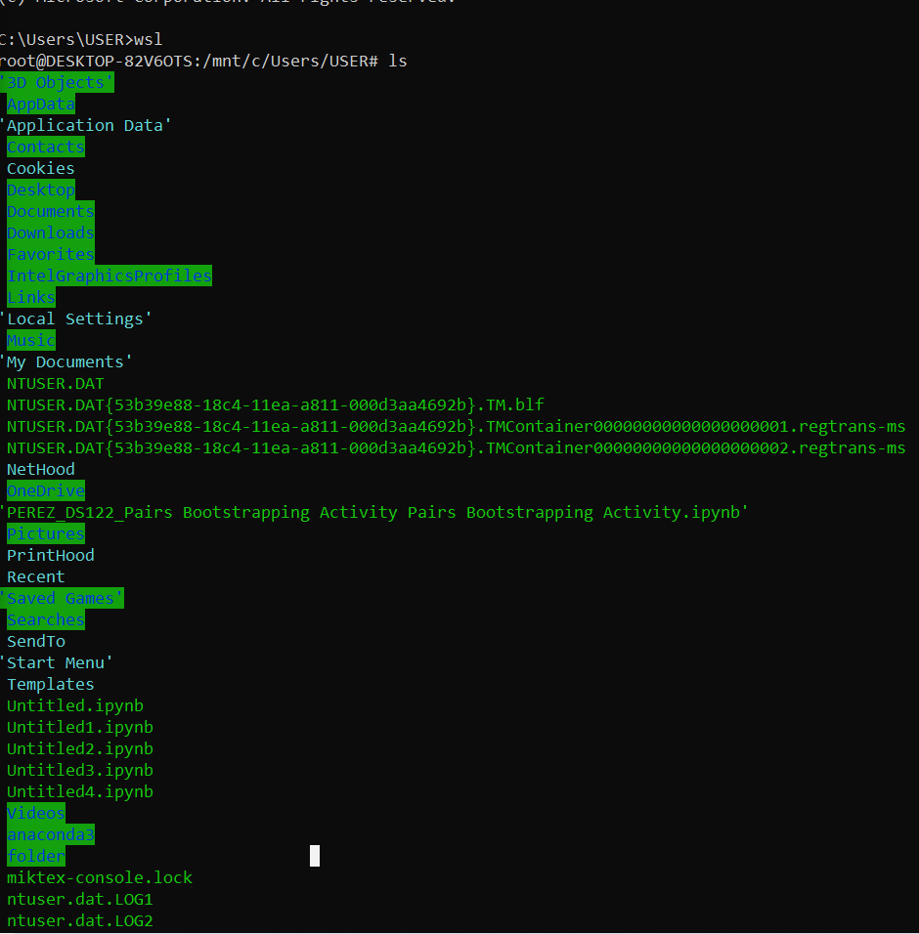

2. The 'pwd' command in Linux stands for "print working directory" and it displays the current directory or path you are in within the file system hierarchy.

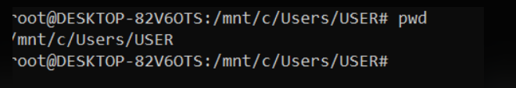

3. The 'mkdir' command in Linux stands for "make directory," and it is used to create a new directory or folder within the file system.

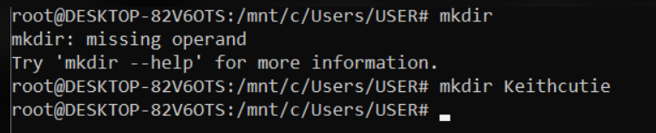

4. The 'mv' command in Linux stands for "move," and it is used to move files or directories from one location to another within the file system, or to rename files and directories.

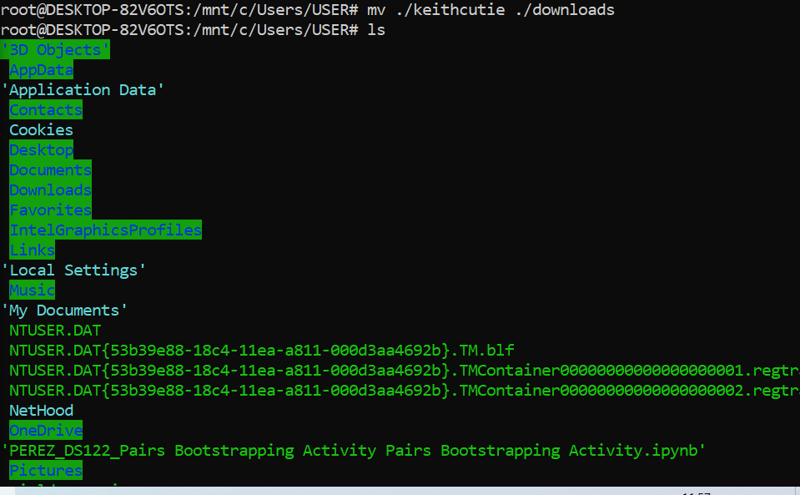

5. here the file keithcutie is move in my downloads since I have done mv ./ keithcutie./downloads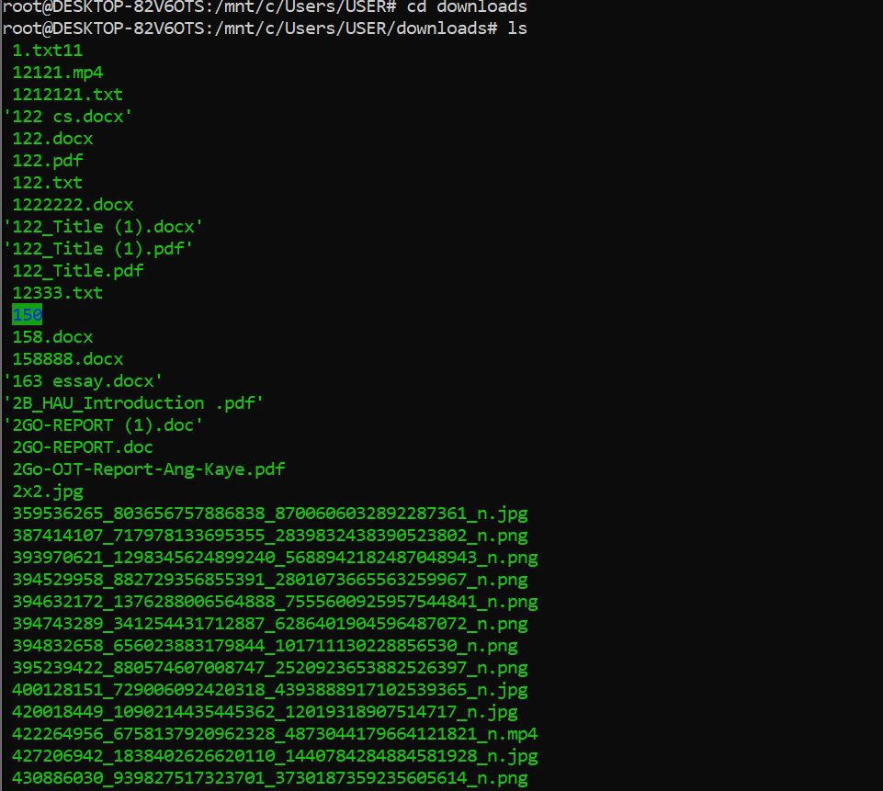

6. The 'rm' command in Linux stands for "remove," and it is used to delete files or directories from the file system.

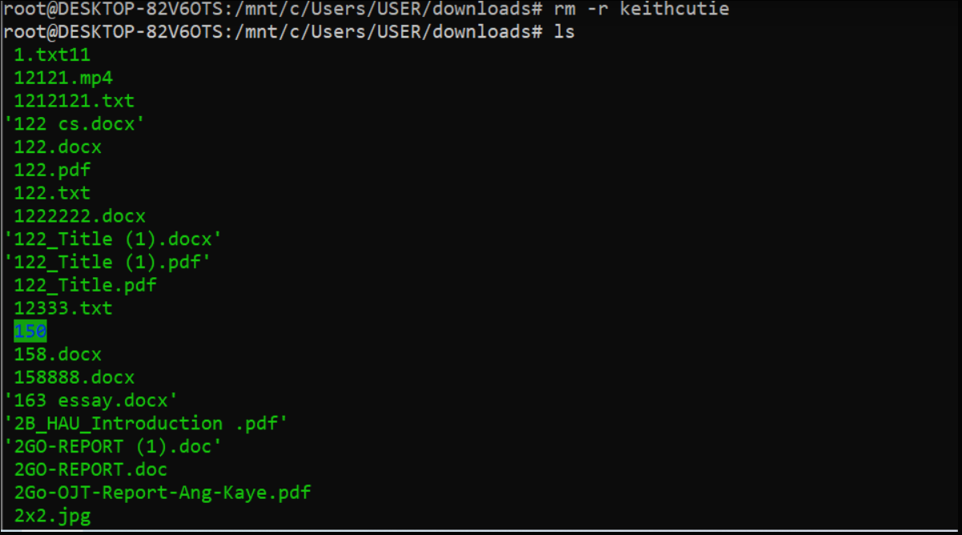

7. The 'cat' command in Linux stands for "concatenate," and it is used to display the contents of one or more files to the standard output (usually the terminal), making it useful for viewing the contents of text files or concatenating multiple files together.

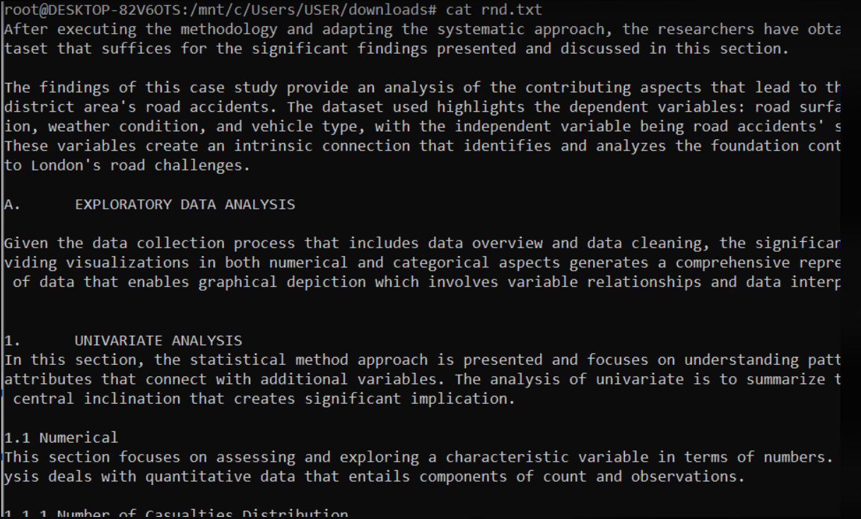

8. The 'tail' command in Linux is used to display the last few lines of a text file, which is particularly useful for viewing the most recent entries in log files or monitoring ongoing processes.

